**Assignment C++**

**Module 4: OOP Concepts**

**Module 4.1: C++ Basic**

**1> Write a program to print “Hello World” using C++.**

**Ans.**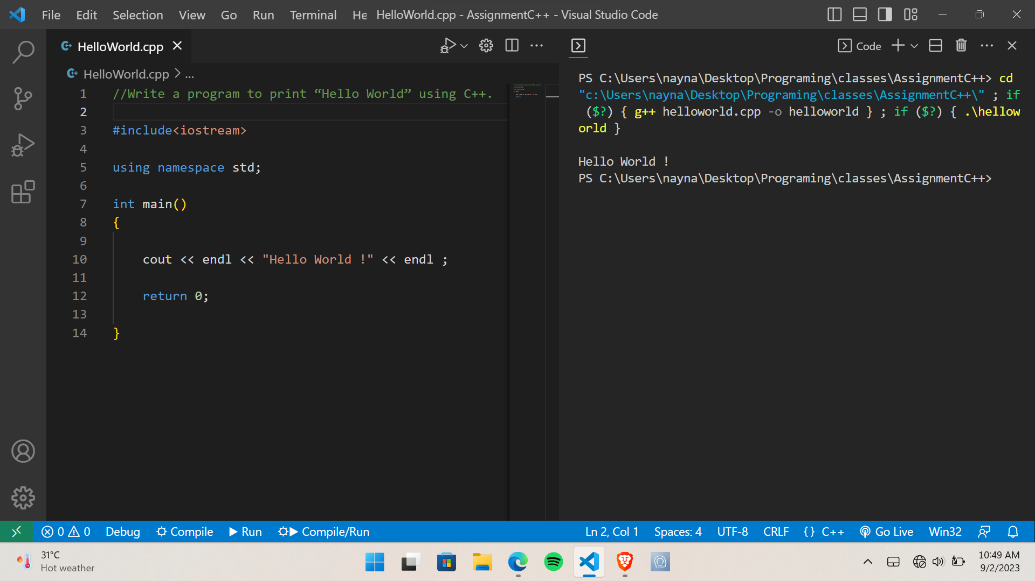

**2> What is OOP? List OOP concepts.**

**Ans.** Object Oriented Programming is a paradigm that supplies many concepts such as **inheritance, data binding, polymorphism etc.**

The programming paradigm where everything is represented as an object is known as truly object-oriented programming language. **Smalltalk** is considered as the first truly object-oriented programming language.

**OOP Concepts are following below:**

**Object** means a real word entity such as pen, chair, table etc. **Object-Oriented Programming** is a method or paradigm to design a program using classes and objects. It simplifies the software development and maintenance by supplying some concepts:

* Object
* Class
* Inheritance
* Polymorphism
* Abstraction
* Encapsulation

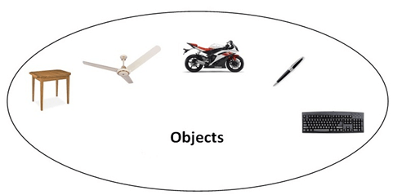

### **--> Object:**

Any entity that has a state and behavior is known as an object. For example: chair, pen, table, keyboard, bike etc. It can be physical and logical.

### **--> Class:**

**Collection of objects** is called class. It is a logical entity.

A Class in C++ is the foundational element that leads to Object-Oriented programming. A class instance must be created to access and use the user-defined data type's data

members and member functions. An object's class acts as its blueprint. Take the class of cars as an example. Even if different names and brands may be used for different cars, all of them will have some characteristics in common, such as four wheels, a speed limit, a range of miles, etc. In this case, the class of car is represented by the wheels, the speed limitations, and the mileage.

### **--> Inheritance:**

**When one object gets all the properties and behaviors of the parent object,** i.e., known as inheritance. It supplies code reusability. It is used to achieve runtime polymorphism.

1. Sub class - Subclass or Derived Class refers to a class that receives properties from another class.
2. Super class - The term "Base Class" or "Super Class" refers to the class from which a subclass inherits its properties.
3. Reusability - As a result, when we wish to create a new class, but an existing class already holds some of the code we need, we can generate our new class from the old class thanks to inheritance. This allows us to use the fields and methods of the pre-existing class.

### **--> Polymorphism:**

When **one task is performed in separate ways,** i.e., known as polymorphism. For example: to convince the customer differently, to draw something e.g., shape or rectangle etc.

Different situations may cause an operation to behave differently. The type of data used in the operation decides the behavior.

**--> Abstraction: Hiding internal details and showing functionality** is known as abstraction. Data abstraction is the process of exposing to the outside world only the information that is necessary while concealing implementation or background information. For example: phone call, we do not know the internal processing.

In C++, we use abstract class and interface to achieve abstraction.

### **--> Encapsulation:**

**Binding (or wrapping) code and data together into a single unit is known as encapsulation.** For example: capsule, it is wrapped with different medicines.

Encapsulation is typically understood as the grouping of related pieces of information and data into a single entity. Encapsulation is the process of tying together data and the functions that work with it in object-oriented programming. Look at a practical illustration of encapsulation: at a company, there are various divisions, including the sales division, the finance division, and the accounts division. All financial transactions are handled by the finance sector, which also supports records of all financial data. In a similar vein, the sales section is in charge of all tasks relating to sales and maintains a record of each sale. Now, a scenario could occur when, for some reason, a financial official requires all the information on sales for a specific month. Under the umbrella term "sales section," all of the employees who can influence the sales section's data are grouped together. Data abstraction or concealing is another side effect of encapsulation. In the same way that encapsulation hides the data. In the example, any other area cannot access any of the data from any of the sections, such as sales, finance, or accounts.

**--> Dynamic Binding -** In dynamic binding, a decision is made at runtime regarding the code that will be run in response to a function call. For this, C++ supports virtual functions.

**--> Advantage of OOPs over Procedure-oriented programming language:**

1. OOPs makes development and maintenance easier whereas in Procedure-oriented programming language it is not easy to manage if code grows as project size grows.
2. OOPs provide data hiding whereas in Procedure-oriented programming language global data can be accessed from anywhere.
3. OOPs provide the ability to simulate real-world events much more effectively. We can provide the solution of real word problem if we are using the Object-Oriented Programming language.

## **--> Why do we need oops in C++?**

There were various drawbacks to the early methods of programming, as well as poor performance. The approach couldn't effectively address real-world issues since, like procedural-oriented programming, you couldn't reuse the code within the program again, there was difficulty with global data access, and so on.

With the use of classes and objects, object-oriented programming makes code maintenance simple. Because inheritance allows for code reuse, the program is simpler because you do not have to write the same code repeatedly. Data hiding is also provided by ideas like encapsulation and abstraction.

## **--> Why is C++ a partial oop?**

The object-oriented features of the C language were the primary motivation behind the construction of the C++ language.

The C++ programming language is categorized as a partial object-oriented programming language even though it supports OOP concepts, including classes, objects, inheritance, encapsulation, abstraction, and polymorphism.

1) The main function must always be outside the class in C++ and is required. This means that we may do without classes and objects and have a single main function in the application.

It is expressed as an object in this case, which is the first time Pure OOP has been violated.

2) Global variables are a feature of the C++ programming language that can be accessed by any other object within the program and are defined outside of it. Encapsulation is broken here. Even though C++ encourages encapsulation for classes and objects, it ignores it for global variables.

## **--> Overloading:**

Polymorphism also has a subset known as overloading. An existing operator or function is said to be overloaded when it is forced to operate on a new data type.

**3> What is the difference between OOP and POP?**

**Ans.**

|  |  |
| --- | --- |
| **OOP** | **POP** |
| **1.**OOP takes a bottom-up approach in designing a program. | **1.** POP follows a top-down approach. |
| **2.** Program is divided into objects depending on the problems. | **2.** Program is divided into small chunks based on the functions. |
| **3.** Each object controls it’s on data. | **3.** Each function contains different data. |
| **4.** Data hiding is possible in OOP. | **4.** No easy way for data hiding. |
| **5.** Inheritance is allowed in OOP. | **5.** No such concept of inheritance in POP. |
| **6.** Operator Overloading is allowed. | **6.** Operator Overloading is not allowed. |
| **7.** Focuses on security of the data irrespective of the algorithm. | **7.** Follows a systematic approach to solve the problem. |
| **8.** The main priority is data rather than functions in a program. | **8.** Functions are more important than data in a program. |
| **9.** The functions of the objects are linked via message passing. | **9.** Different parts of a program are interconnected via parameter passing . |
| **10.** Example of OOP is C++, Java, etc., | **10.** Example of POP is Pascal, Fortran, etc., |

**Module 4.2: Programming with C++**

**1> Write a program to create simple calculator using class.**

**Ans.**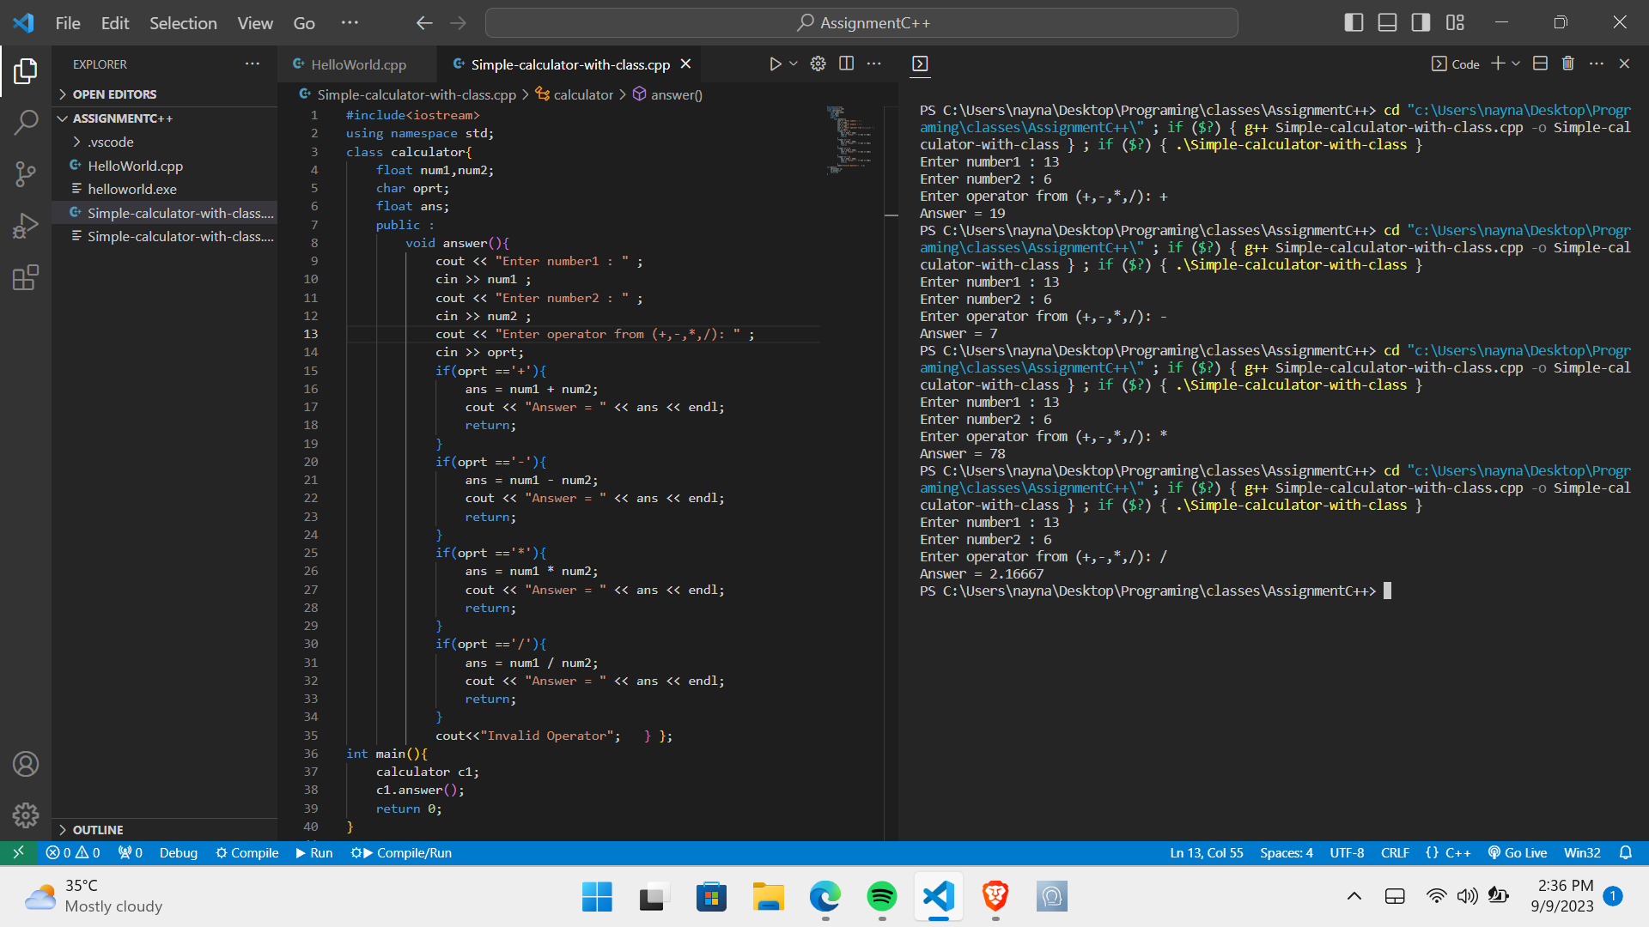

**2>** **Define a class to represent a bank account. Include the following members:**

**1. Data Member:**

**-Name of the depositor**

**-Account Number**

**-Type of Account**

**-Balance amount in the account**

**2. Member Functions:**

**-To assign values**

**-To deposit an amount**

**-To withdraw an amount after checking balance**

**-To display name and balance**

**Ans.**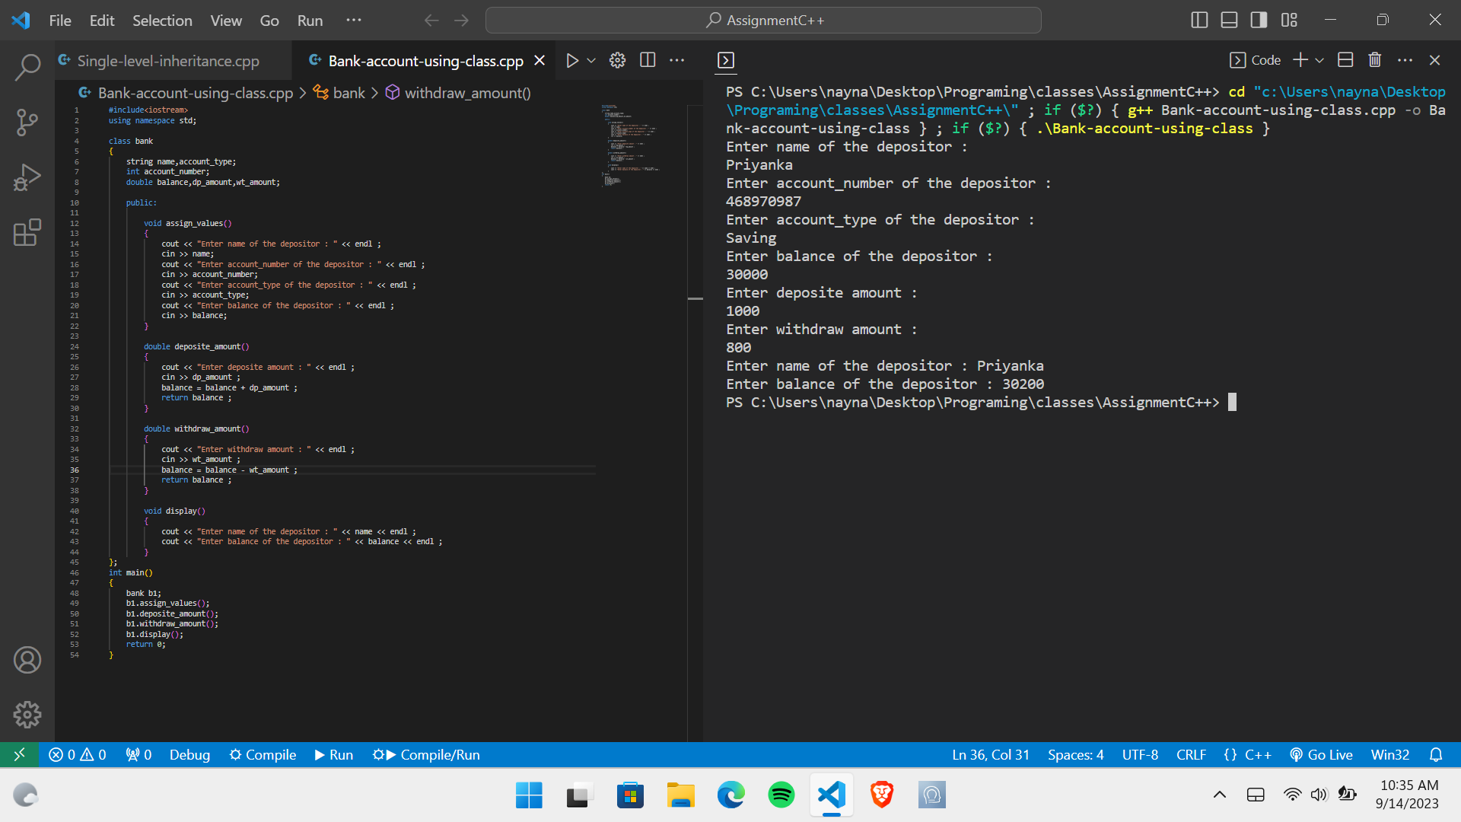

**3>** **Write a program to find the multiplication values and the cubic values using inline function.**

**Ans.**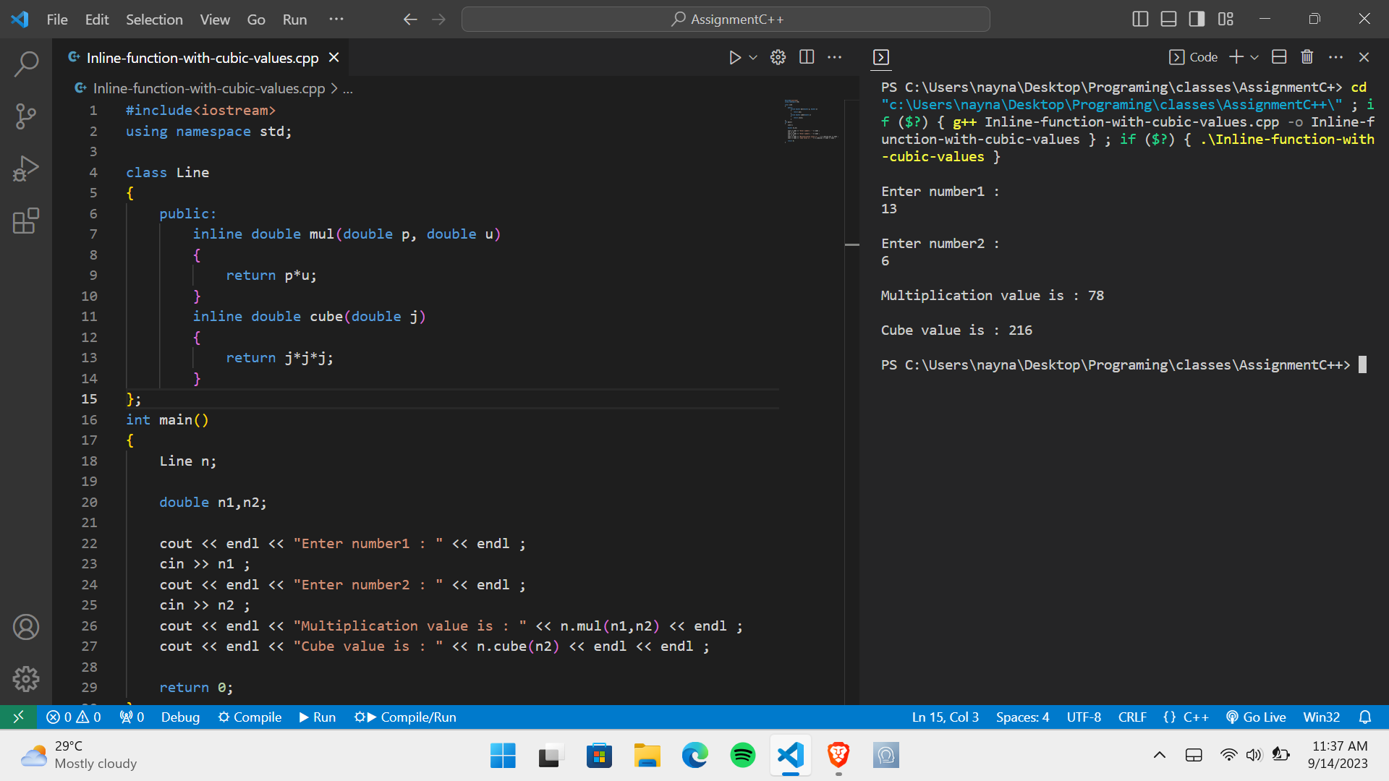

**4>** **Write a program of Addition, Subtraction, Division, Multiplication using constructor.**

**Ans.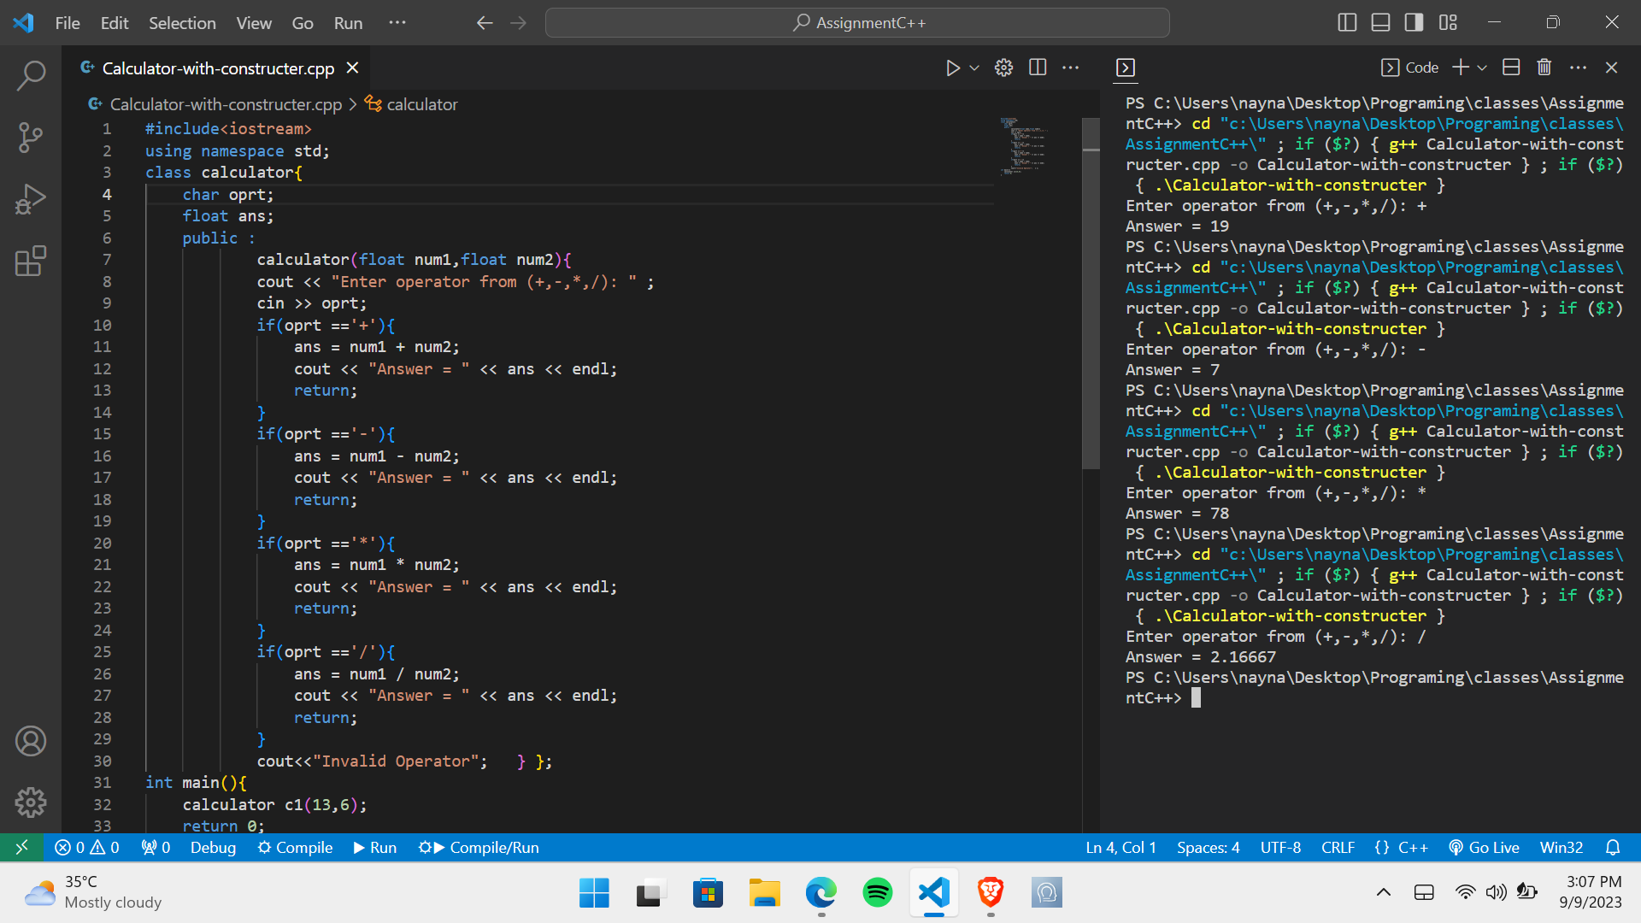5> Assume a class cricketer is declared. Declare a derived class batsman from cricketer. Data member of batsman. Total runs, Average runs and best performance. Member functions input data, calculate average runs, Display data (Single Inheritance).**

**Ans.**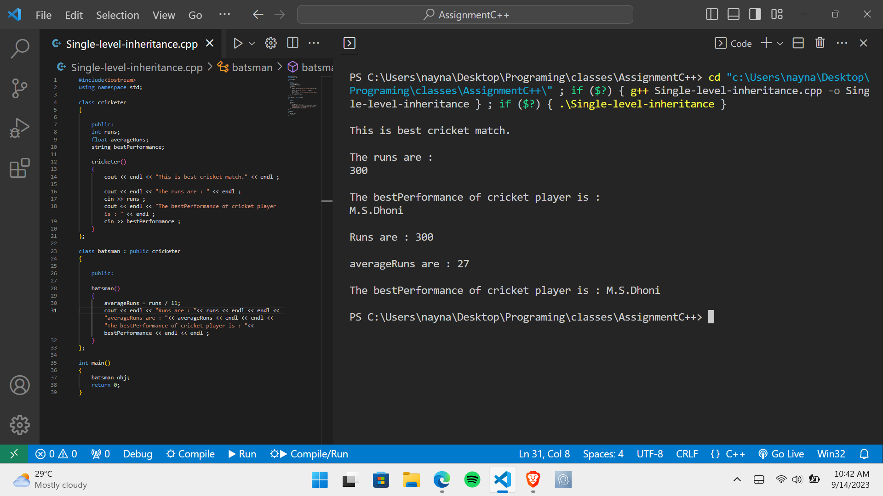

**6>** **Create a class person having members name and age. Derive a class student having member percentage. Derive another class teacher having member salary. Write necessary member function to initialize, read and write data. Write also Main function (Multiple Inheritance).**

**Ans.**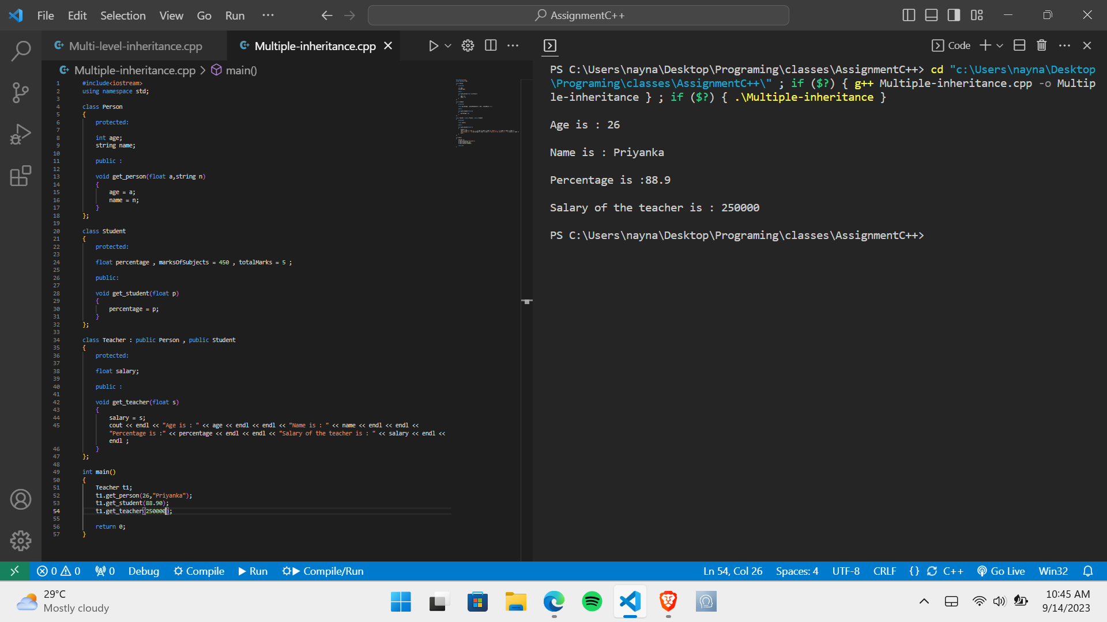

**7>** **Assume that the test results of a batch of students are stored in three different classes. Class Students are storing the roll number. Class Test stores the marks obtained in two subjects and class result contains the total marks obtained in the test. The class result can inherit the details of the marks obtained in the test and roll number of students (Multilevel Inheritance).**

**Ans.**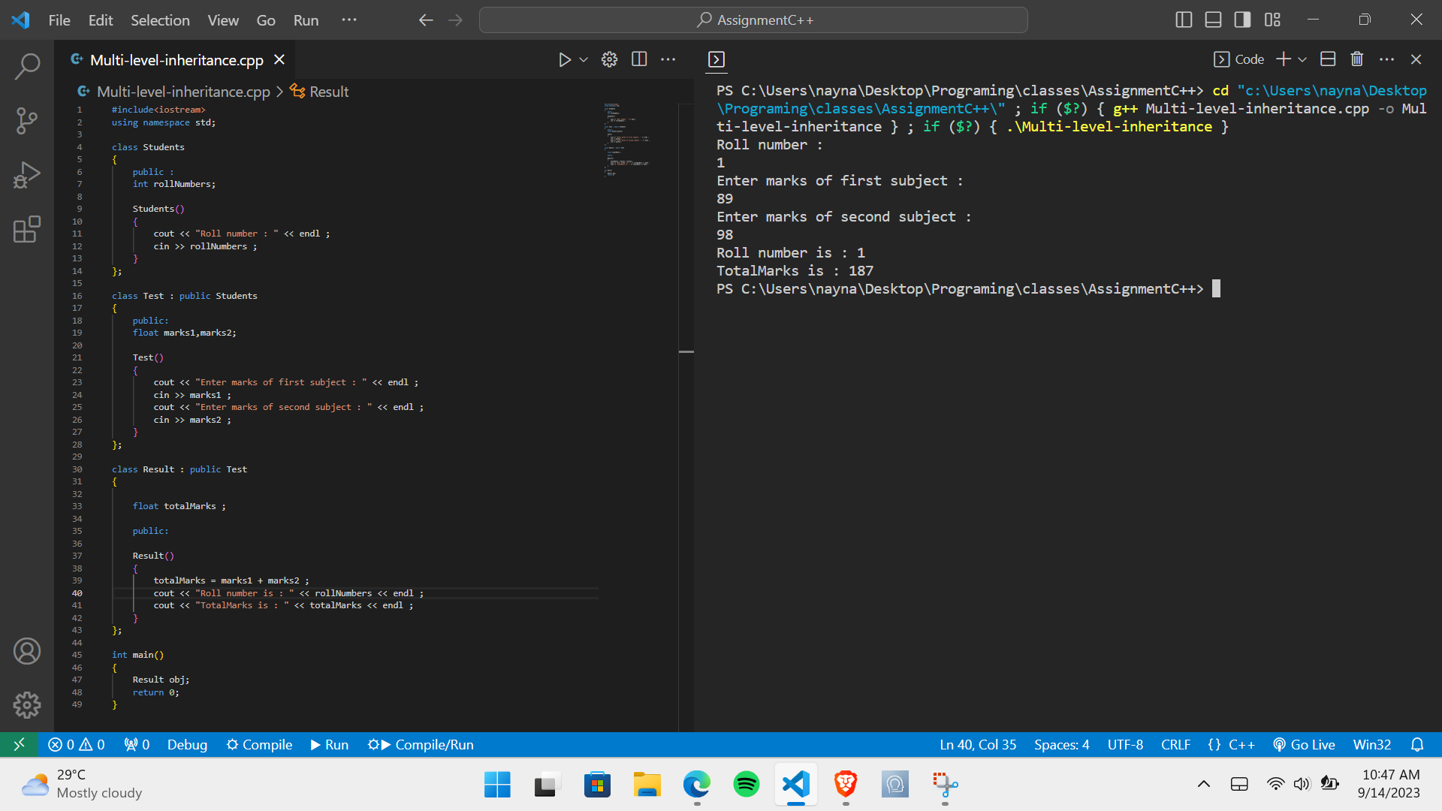

**8>** **Write a program to Mathematic operation like Addition, Subtraction, Multiplication, Division Of two number using different parameters and Function Overloading.**

**Ans.**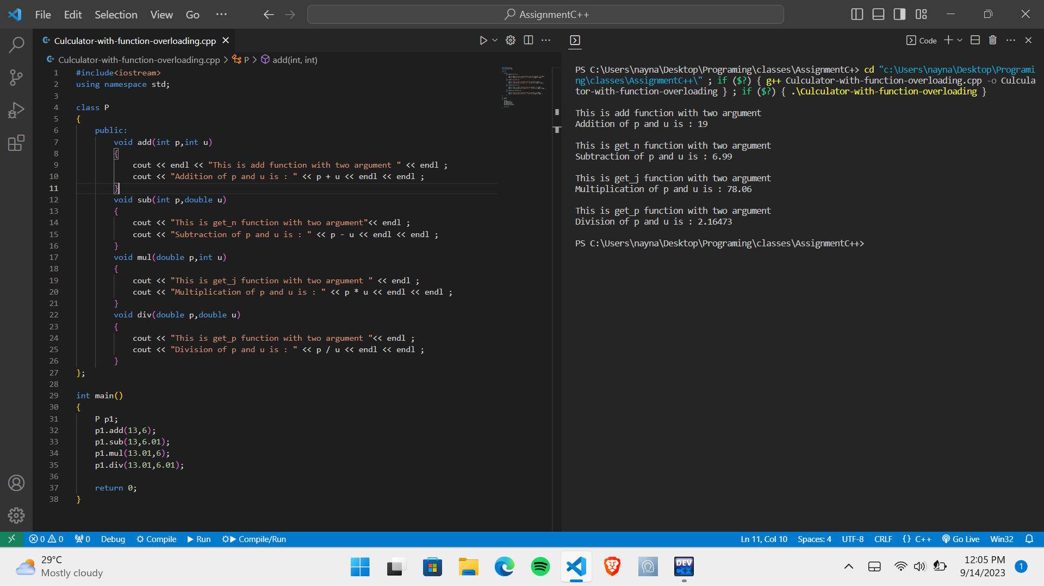

**9>** **Write a program to calculate the area of circle, rectangle and triangle using Function Overloading.**

**- Rectangle: Area * breadth**

**- Triangle: ½ *Area* breadth**

**- Circle: Pi * Area *Area**

**Ans.**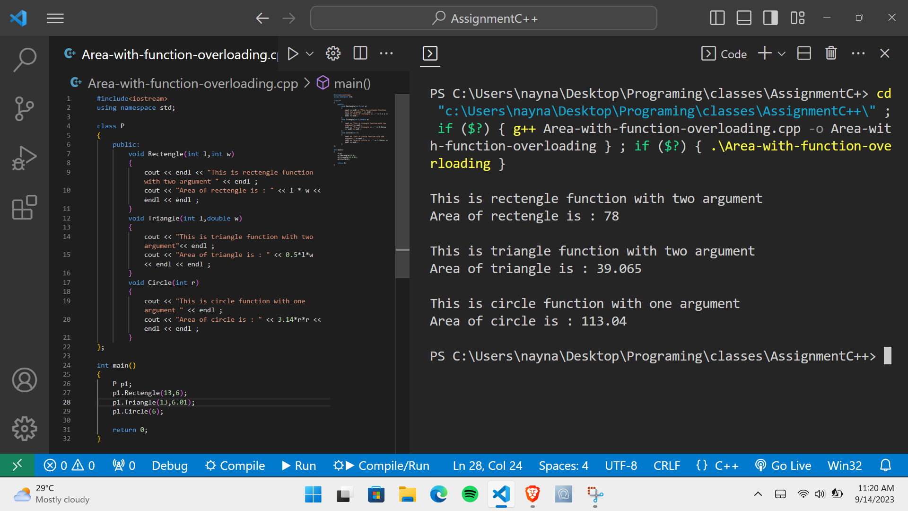

**10>** **Write a Program of Two 1D Matrix Addition using Operator Overloading.**

**Ans.**

**11> Write a program to concatenate the two strings using Operator Overloading.**

**Ans.**

**12>** **Write a program to swap the two numbers using friend function without using third variable.**

**Ans.**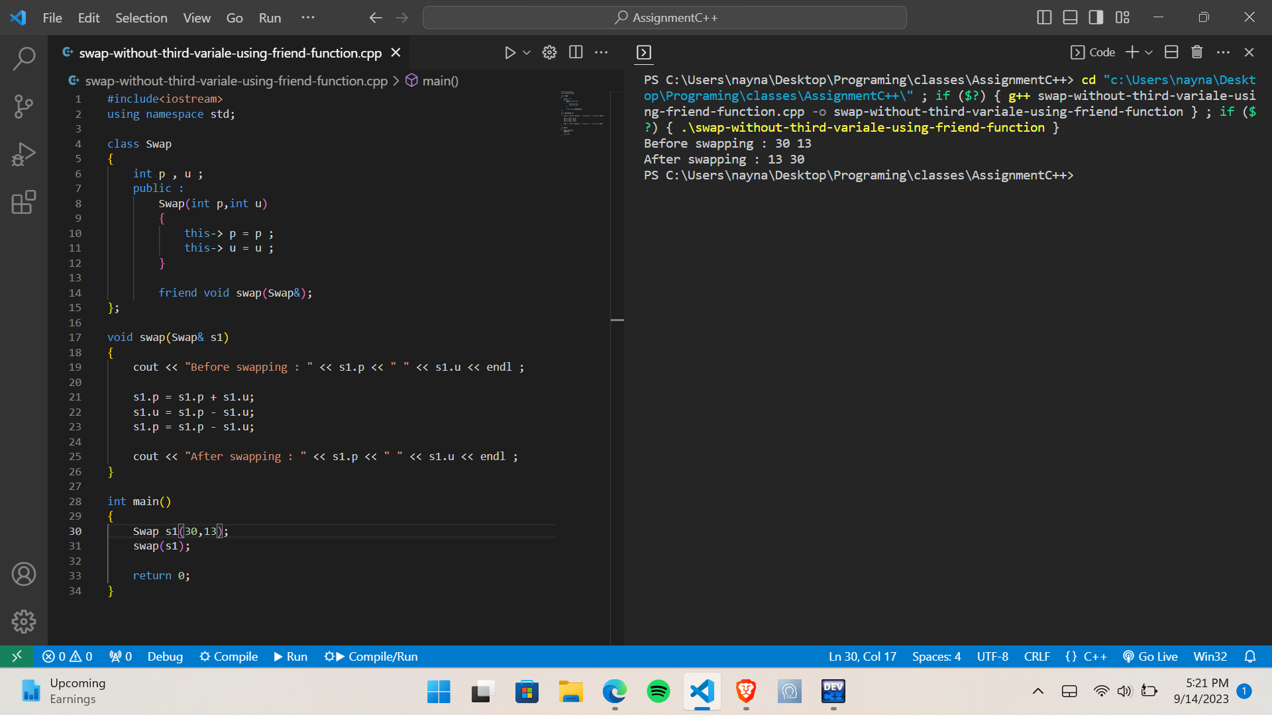

**13>** **Write a program to find the max number from given two numbers using friend function.**

**Ans.**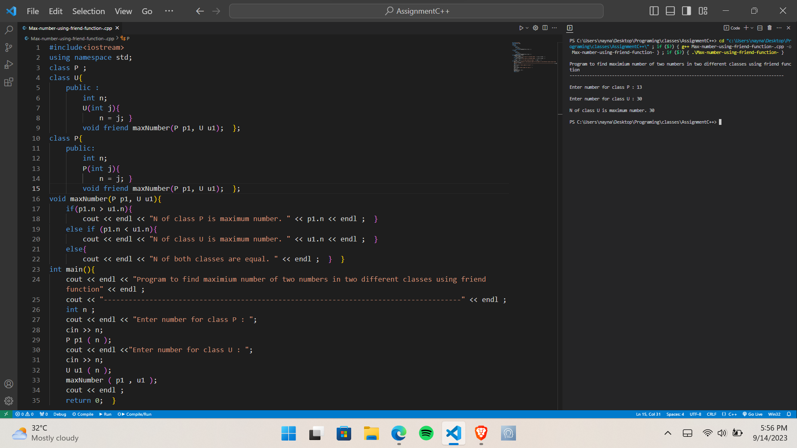

**Module 4.3: C, C++ Templates**

**1>** **Write a program to swap the two values using templates.**

**Ans.**

**2>** **Write a program to sort the array using templates.**

**Ans.**